ACTIVITY 7: Building a LinkedIn Profile

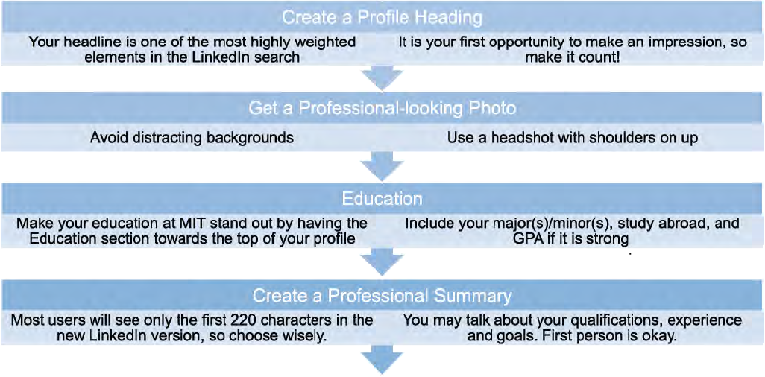
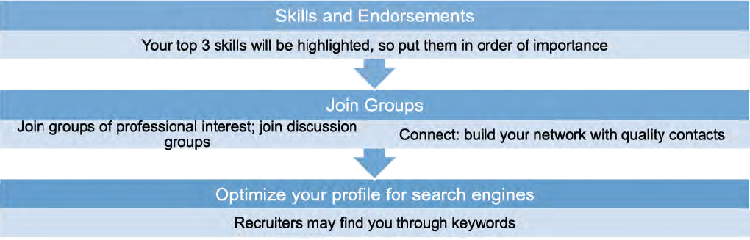
Benefits
- Each month, 187 million users visit LinkedIn.
- LinkedIn:

o provides an online professional presence
o contains content from your resume, cover letter, and references for others to see
o is a networking site that allows you to make new professional connections
o contains access to job listings
o contains Information for research on companies or people you are going to meet
o has a students’ job portal: http://www.linkedIn.com/studentjobs

